**Modelling the effects of livestock antibiotic usage on human food-borne disease**

**ABSTRACT**

Excessive livestock antibiotic usage has been proposed as a major driver of antimicrobial resistance in human populations. This has led to antibiotic stewardship programs which aim to curtail usage of livestock antibiotics through a “one-health” approach. However, the consequences of livestock antibiotic curtailment are poorly understood. In particular, the potential for increases in the carriage of foodborne pathogens in livestock, due to a loss of antibiotic pressure, and subsequent increases in human foodborne disease. Here we use a mathematical model to explore the impact of curtailing livestock antibiotic usage on both antibiotic-sensitive and antibiotic-resistant food-borne disease in humans.

The model identified potential increases in overall human food-borne disease and a decrease in resistant human disease following livestock antibiotic curtailment. However, this can be mitigated through interventions to reduce animal-to-human transmission, and to a lesser extent, animal-to-animal transmission and the background rate of contamination in livestock. The magnitude of interventions needed to mitigate increases in human foodborne disease was found to vary across different case studies, suggesting that a “one-size fits all approach” across different agricultural settings, livestock hosts and drug/bug combinations will likely not be successful. This work provides an illustrative example of one of the potential consequences of antibiotic withdrawal and how agricultural biosecurity interventions can be employed to mitigate potential negative human health consequences following livestock antibiotic stewardship programs.

**INTRODUCTION**

Antimicrobial resistance (AMR) has been highlighted as one of the largest current threats to human health, with a growing number of key antibiotic therapeutics being rendered ineffective by resistant bacterial pathogens. Excessive livestock antibiotic usage has been identified as a potentially important driver of AMR in human populations, with cross-species transmission of resistant bacteria and resistance determinants possibly occurring at the livestock/human interface (**CITE**). This has led to calls to curtail the usage of livestock antibiotics, with legislature such as the 2006 European Union ban and 2017 US Food Drug Administration regulation on antibiotic growth promotion, aiming to safeguard the efficacy of clinical antibiotics and reduce the potential for zoonotic transmission of resistant pathogens to human populations (**CITE**). However, the relationship between livestock antibiotic usage and antibiotic-resistant/sensitive human food-borne disease remains poorly understood.

A range of beneficial outcomes have been reported as a consequence of livestock antibiotic curtailment, including decreased faecal *Enterococci* resistance rates in livestock and humans in Denmark and Germany resulting from the 2006 growth promotion ban (**CITE**). However, AMR literature has also identified transient increases in the carriage of other resistant pathogens, increases in livestock carriage of food-borne pathogens and increases in therapeutic livestock antibiotic usage following antibiotic curtailment (**CITE**). These negative consequences have been suggested to be attributable to increases in livestock production in the years following the European ban on antibiotic-mediated growth promotion and due to other resistance-related genetic factors (**CITE**). However, the unforeseen nature of these potential consequences highlights the risks of introducing substantial interventions into highly complex and poorly understood systems as part of a “precautionary principle” based approach (**CITE**). The need to better understand the potential long-term impacts of future AMR policy is also likely to increase in coming years, with new EU legislation strictly controlling the use of livestock antibiotics for metaphylaxis or prophylaxis by 2022 (**CITE**).

One approach to better understand the complexities of livestock antibiotic usage includes the use of theoretical mathematical models, which are simplified representations of complex real-world systems. These models can help supplement current genomic approaches by hypothesis testing various uncertainties in AMR modelling literature, especially regarding the potential effects of livestock antibiotic usage on human health and the extent of AMR transmission at the livestock/human interface. However, there is a severe dearth of models which quantitatively explore these uncertainties (**CITE**). Existing frameworks include predictive risk assessment models and a small number of generalised deterministic models (**CITE**). However, a significant number of knowledge gaps still exist, including a lack of understanding of the potential consequences resulting from livestock antibiotic curtailment and the impact of different mitigating scenarios on altering these outcomes.

To address some of the gaps in AMR modelling literature, a simple deterministic model was developed to explore a motivating example of the effects of livestock antibiotic curtailment on common food-borne infections in humans across a range of different case-studies. By explicitly modelling both livestock/human populations and various assumptions regarding the effects of livestock antibiotic usage, the model can explore the potential long-term consequences of livestock antibiotic curtailment, including alterations to the overall prevalence of human food-borne disease and the antibiotic-resistant fraction. Additionally, the model will explore the effects and feasibility of introducing supplemental interventions to mitigate the potential negative consequences of livestock antibiotic curtailment.

**METHODOLOGY**

1. **Model Structure and Description**

A deterministic compartmental model, based on a standard SI-model structure (**CITE**), was developed to describe the transmission of antibiotic-resistant and antibiotic-sensitive food-borne bacteria within/between livestock and human populations (**Figure 1**). Each host population can be sub-divided into three compartments based on their respective infection status: susceptible humans (SH), humans infected with antibiotic-sensitive bacteria (ISH), humans infected with antibiotic-resistant bacteria (IRH), susceptible livestock food-animals (SA), livestock food-animals infected with antibiotic-sensitive bacteria (ISA) and livestock food-animals infected with antibiotic-resistant bacteria (IRA).

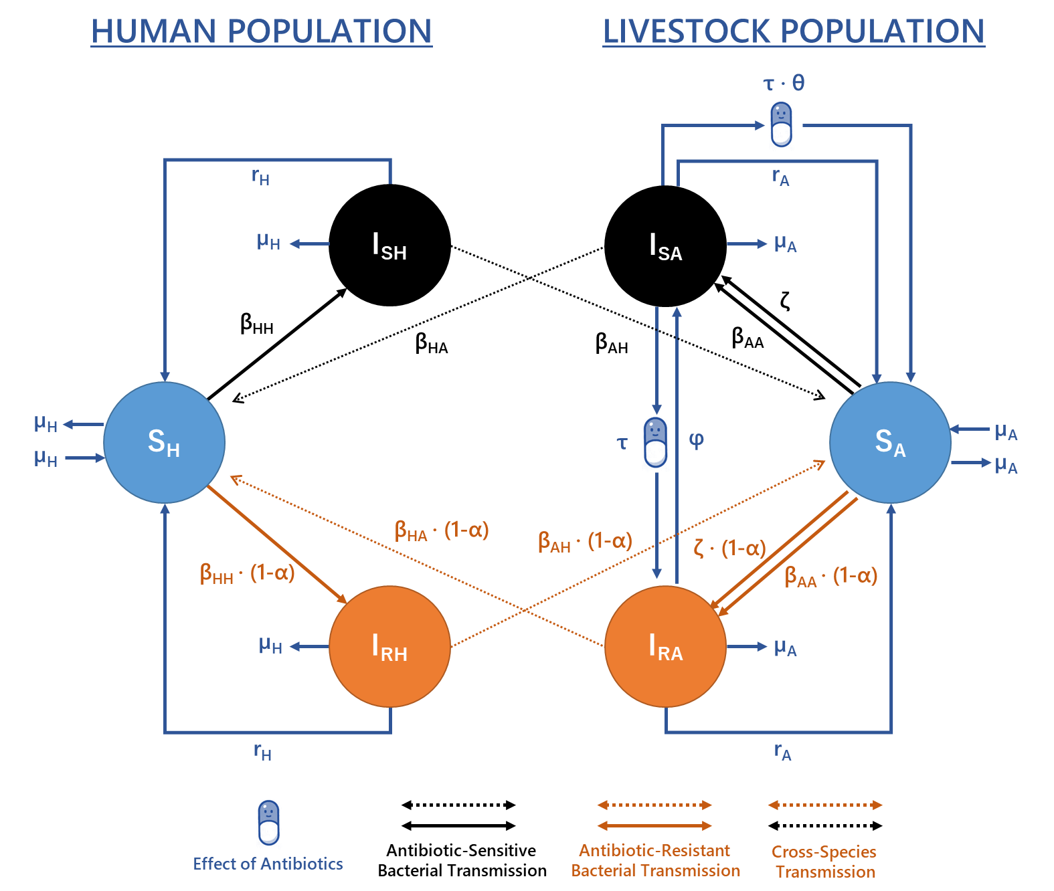

**Figure 1 – Model structure describing the transmission of food-borne pathogens between/within livestock and human populations.** Model equations and parameters can be found described in the supplementary material (Table S2).

Transmission is simplified into four transmission routes: animal-to-animal (*βAA*), human-to-human (*βHH*), animal-to-human (*βHA*) and human-to-animal (*βAH*) transmission, with each *β* parameter linearly describing both indirect and direct transmission between compartments for model tractability. A background rate of transmission in the livestock population was also modelled (*ζ*), representing infection/contamination of livestock hosts from sources other than other livestock or humans.

Natural recovery from antibiotic-sensitive/resistant infection occurs in both human/livestock populations at rate *rH* and *rA* respectively. Per capita birth/death rates are represented by *µA* in animal and µH in human populations. To model the assumption that livestock antibiotic usage (*τ*) has therapeutic effects within livestock populations, antibiotic usage was assumed to increase the rate of livestock recovery from infection (*τ* + *rA*). Livestock antibiotic usage was also assumed to mediate conversion from antibiotic-sensitive to antibiotic-resistant infection (ISA → IRA).

A reversion parameter (*φ*) independent of antibiotic usage was also included to model the reversion of antibiotic-resistant infection to antibiotic-sensitive infection (IRA → ISA). We model this as a generic term used to encompass a wide range of potential ecological and evolutionary mechanisms. This could include an implicit majority-minority relationship between resistant/sensitive strains, strain competition dynamics, growth-related fitness costs of resistance or de-novo evolution of resistance. However, it was beyond the scope of this study to explicitely model these dynamics, rather we describe and acknowledge the *existence* of bidirectional resistance conversion though this simplified *φ* parameter (**SPICKNALL CITE**). Additionally, we note that modelling within-host strain dynamics or dual-strain colonisation was beyond the scope of this study, therefore resistance was modelled as a binary phenomenon within both livestock and humans (**null neutral model - CITE**).

To reduce the linearity associated with livestock antibiotic usage on both livestock recovery and antibiotic-resistance conversion, a scaling parameter was introduced (*θ*) to model the relative efficacy of antibiotic mediated recovery in livestock. Transmission-related fitness costs associated with antibiotic-resistance were included and were assumed to reduce the rate of transmission for antibiotic-resistant bacteria as a scaling factor (1-*α*) (**CITE**).

The per capita death rate of the human and livestock population was taken as the reciprocal of the average human life expectancy in Western Europe and the average age at which livestock pigs reach market weight before slaughter in Europe (**CITE**). The per capita rate of recovery from infection was taken as the reciprocal of the average time taken to recover from food-borne disease in humans, and the estimated time taken for a livestock swine to stop shedding *Salmonella* bacteria (**CITE**). Two primary outcome measures were considered in this study: overall incidence of human non-typhoidal salmonellosis per 100,000 population (ICombH) and the fraction of antibiotic-resistant human foodborne infection (ResProp).

1. **Case Study and Model Parameterisation**

Four case studies were chosen to ground the model with epidemiological surveillance data. These case studies were: 1) tetracycline-resistant non-typhoidal salmonella in fattening pigs to humans from 2015-2018 (**CITE**), 2) ampicillin-resistant non-typhoidal salmonella in fattening pigs to humans from 2015-2018 (**CITE**), 3) tetracycline-resistant non-typhoidal salmonella in broiler poultry to humans from 2014-2018 (**CITE**) 4) ampicillin-resistant non-typhoidal salmonella in broiler poultry to humans from 2014-2018 (**CITE**).

* These case studies were included due to their significant positive relation between antibiotic usage and resistance using a linear regression model and with one study being borderline significant (p value) – this was included.
* It is important to note that for each case study – each individual data point refers to a particular antibiotic usage and resistance combination for a particular EFSA and ESVAC data combination.
* All country/years combinations in the EFSA dataset were removed if the number of samples (N) was below 10 (as per EFSA guidelines), therefore all data points represent a number of tested samples of above or equal to 10.
* It is important to note that there is an assumption that the inclusion of yearly data that the usage or resistance is either at equilibrium – or that there is no lag – i.e. that the reduction in antibiotic usage across two years – that the level of resistance seen in the second year is representative of the usage in that second year – and not still influenced by the usage dynamics seen in the year before.
* The case studies are also justifiable due to penicillin and tetracycline usage (as well as sulphonamides) being the livestock antibiotics with the highest level of usage.

In accordance with the EFSA guidelines, countries with <10 isolates in the respective EFSA dataset were omitted from the model fit to preserve the integrity of the dataset when fitting. These case studies were chosen due to the high level of agricultural usage, high prevalence of resistance in humans/livestock populations.

Using an approximate Bayesian computation sequential Monte-Carlo (ABC-SMC) model fitting approach, three summary statistics were used to fit the study model to epidemiological surveillance data. A detailed methodology of the ABC-SMC approach can be found in **Toni et al, (2009)** (**CITE**). A multivariate normal distribution chosen for the ABC-SMC perturbation kernel (**CITE**). The summary statistics were as follows:

1. Minimise the sum of squares (**eqn 1.1**) between the estimated model relationship between livestock antibiotic usage and the proportion of resistant livestock infections obtained and the observed relationship between EFSA country level resistance data and ESVAC country-level antibiotic sales data (**CITE**). Note that this relationship was modelled specifically for each drug/bug combination case study considered. ESVAC data was averaged for each country in the original dataset, therefore a scaling calculation was used to make each antibiotic usage level specific to the modelled livestock host. Details of this can be found in the **supplementary information**. Note that due to a lack of accurate country-level antibiotic usage data, sales were assumed to be accurate proxy for usage.

eqn 1.1

1. Minimizing the difference between the model estimated overall daily incidence of human salmonellosis at baseline antibiotic usage and the ECDC overall daily incidence of human salmonellosis currently observed (0.593 per 100,000). Note that yearly incidence data was converted to a daily incidence estimate for use in this model. Details of this conversion is described in the **supplementary information**.
2. Minimising the difference between the model estimated proportion of resistant human salmonellosis at baseline antibiotic usage and the EFSA averaged European proportion of resistant human salmonellosis specific for each case study.

The ABC-SMC approach was used to fit the model for five free parameters: the per capita rate of animal-to-animal transmission (*βAA*), efficacy of antibiotic-mediated recovery (*θ*), per capita rate of antibiotic-resistant to antibiotic-sensitive reversion (*φ*), transmission-related fitness costs of resistance (*α*) and background rate of transmission to livestock populations (*ζ*). Other model parameters were not fitted due to available information (rH, rA, μA and μH), or due to the relative nature of other transmission parameters (*βHA*, *βHH* and *βAH*). These latter parameters were instead held at static values based on a hierarchy of transmission magnitudes (*βAA* > *βHA* = *βHH* = *βAH*). Limitation of free model parameters prevented model overfitting and increased the efficiency of the ABC-SMC approach. Initial prior distributions for each parameter can be found in the supplementary material (**Table S3, Figure S1**).

The ABC-SMC model fit was run for five generations, with each generation running until the acceptance of 1000 particles. Epsilon (*ε*) acceptance thresholds for the summary statistics for each generation for can be found in thesupplementary material (**Table S4**). A mean point estimate was taken from the posterior distribution of the fifth generation for each parameter (**CITE – why the mean**). This point estimate was used for the final parameter set for each case study.

1. **Sensitivity Analysis**

A Fourier amplitude sensitivity test (FAST) approach was used to conduct a sensitivity analysis of the model system to the model parameters with regards to two outcome measures (**CITE**): 1) the overall prevalence of human foodborne infection and 2) proportion of resistant human infection. The parameter space range chosen for the sensitivity analysis was limited to an order of magnitude above and below the parameterised values (Table 2). For fitted model parameters, this range was taken as an order of magnitude above and below the average of the fitted point estimate for each parameter across each considered case study.

The FAST approach was also used to identify the sensitivity of the model system to two intervention related outcome measures: 1) Relative changes in ICombH when livestock antibiotics were curtailed (*τ* = 0 g/PCU), compared to ICombH at mean baseline livestock antibiotic usage across the three case studies (*τ* = 0.0102 g/PCU) and 2) Relative changes in ICombH under antibiotic curtailment (0 g/PCU) relative to what is currently observed with current levels of antibiotic usage (3.26 per 100,000). Parameter ranges used are as previously described above.

1. **Software Used**

All simulations were carried out using R and RStudio. R package “desolve” was used for all model simulations. All sensitivity analyses were performed using the FAST and sensitivity R packages (**CITE**). The ABC-SMC approach used “tmvtnorm” and “bayestestR” packages. Plotting used “ggplot2”, “ggpubr”, “metR”, “grid and “gridExtra” R packages. Reproducible code can be found at: <https://github.com/alexmorgan1995/Chapter-2>. (**CITE**).

**RESULTS**

Three case-studies were modelled to explore the human health impact of altering livestock antibiotic sales on human foodborne disease. The modelled case-studies were: tetracycline-resistant non-typhoidal salmonella in fattening pigs to humans, ampicillin-resistant non-typhoidal salmonella in fattening pigs to humans and tetracycline-resistant non-typhoidal salmonella in broiler poultry to humans.

The approximated posterior parameter distribution using an ABC-SMC approach was determined for five model parameters: the per capita rate of animal-to-animal transmission (*βAA*), efficacy of antibiotic-mediated recovery (*θ*), per capita rate of antibiotic-resistant to antibiotic-sensitive reversion (*φ*), transmission-related fitness costs of resistance (*α*) and background rate of transmission to livestock populations (*ζ*) (**Figure 1**). We note that due to the scarcity of livestock AMR data, the resulting model fit was not intended as a prediction or a forecast. Rather the ABC-SMC approach was used to explore roughly parameterised case studies with the best available data, used as an illustrative example to explore the hypotheses and model structure proposed in this study.

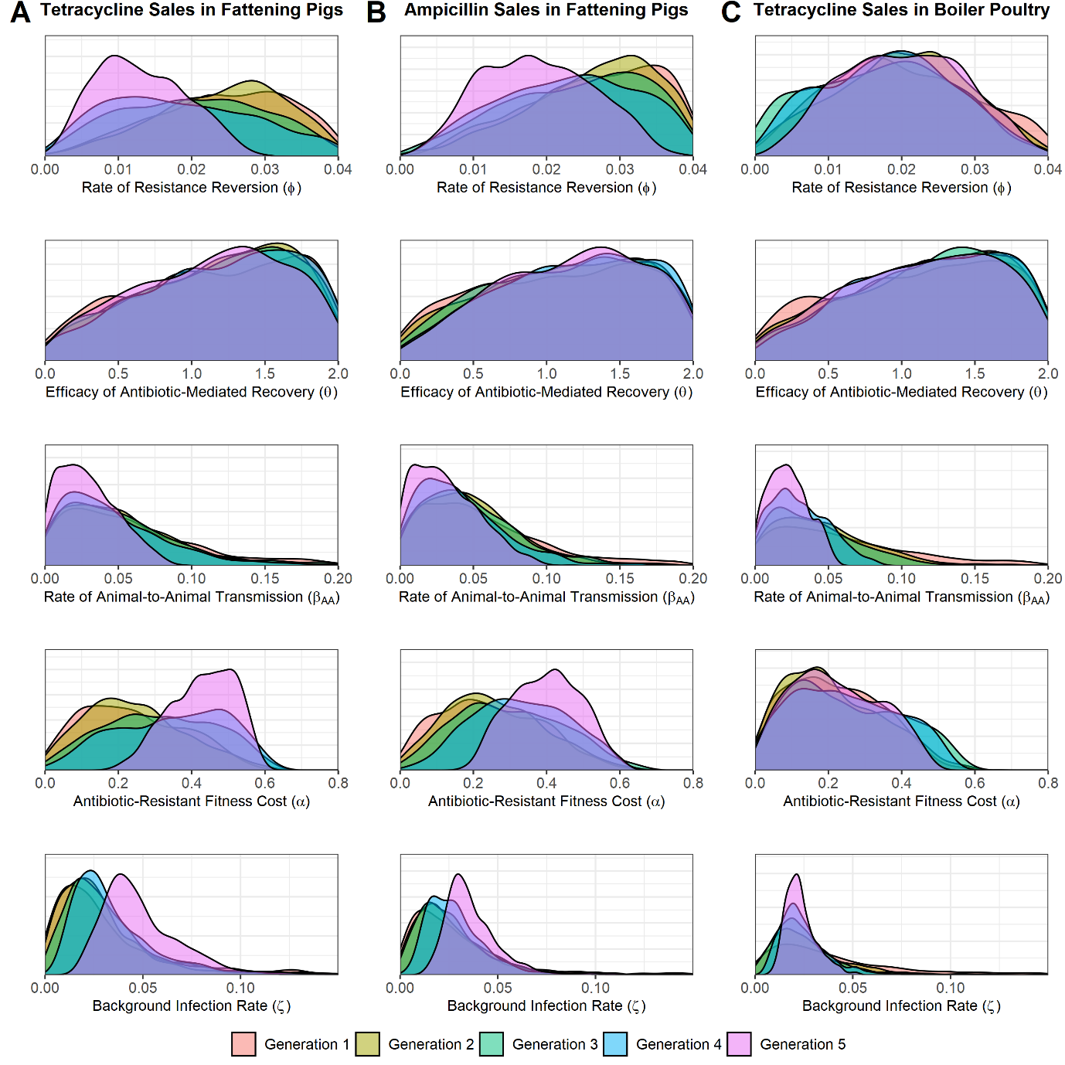

**Figure 1 – Estimated posterior distributions for the rate of animal-to-animal transmission (*βAA*), efficacy of antibiotic-mediated recovery (*θ*), rate of antibiotic-resistant to antibiotic-sensitive reversion (*φ*), transmission-related fitness costs of resistance (*α*) and background rate of transmission to animal populations (*ζ*).** A) Tetracycline sales in fattening pigs. B) Ampicillin sales in fattening pigs. C) Tetracycline sales in broiler poultry. The estimated posterior distribution for each generation is highlighted by fill colours.

The posterior mean from the 5th generation of each parameter posterior distribution was taken as the point estimate to parameterise each case study. The following parameter values were used for each case study, with the sum of squares (SS) for the resulting model fit against the data also described: tetracycline sales for fattening pigs: *βAA* = 0.029, *θ* = 1.131, *φ* = 0.0131, *α* = 0.429 and *ζ* = 0.0497 (SS = **0.494**), ampicillin sales for fattening pigs: *βAA* = 0.0318, *θ* = 0.164, *φ* = 0.0188, *α* = 0.3398 and *ζ* = 0.0379 (SS = 1.**313**) and tetracycline sales for broiler poultry: *βAA* = 0.0229, *θ* = 0.1135, *φ* = 0.0203, *α* = 0.0213 and *ζ* = 0.0233 (SS = **0.526**). The relationship between observed country-level antibiotic sales data and livestock tetracycline/ampicillin-resistance surveillance data was plotted for all three case studies, with the parameterised model estimate overlaid (**Figure 2**).

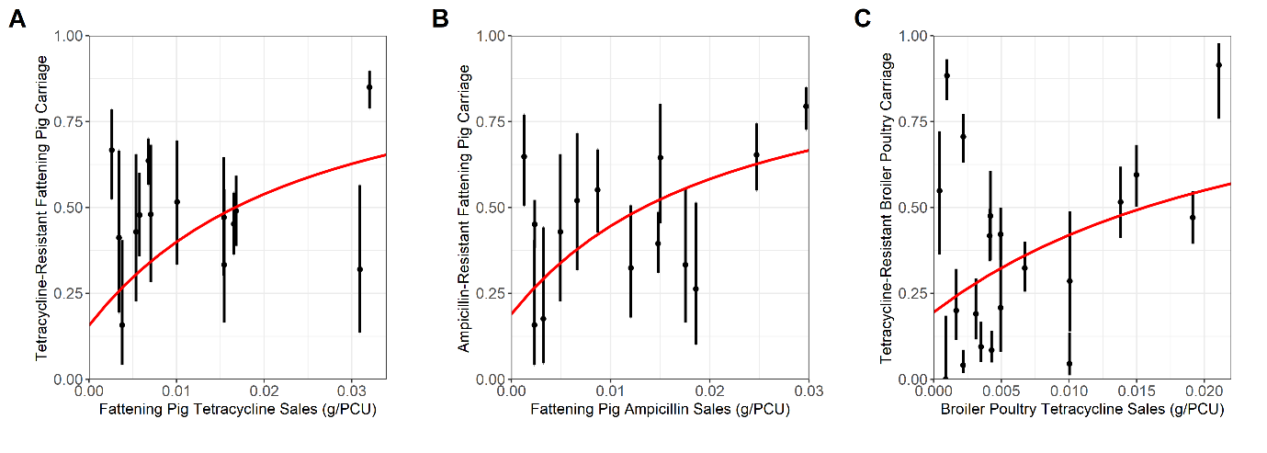

**Figure 2 – Observed and estimated relationship between livestock antibiotic sales data and antimicrobial-resistant salmonellosis in humans. A) Tetracycline-resistance in fattening pigs, B) Ampicillin-resistance in fattening pigs and C) Tetracycline-resistance in broiler poultry. Red line represents the** model fit using the posterior mean from the ABC-SMC model fitting approach for the observed relationship between livestock tetracycline usage and livestock carriage. 95% confidence intervals for the country-level estimate are plotted for each country using a 1-sample proportion test with continuity correction.

A variance-based Fourier amplitude sensitivity testing (FAST) approach was used to explore the sensitvity of ICombH and ResProp outcome measures to the model parameters. The most influential parameters for ICombH were identified as the rate of natural human recovery (*rH*) and the rate of animal-to-human transmission (*βHA*) (**Figure S1A**). ResProp was found to be most sensitive to transmission-related fitness costs (*α*), livestock antibiotic usage (*τ*), antibiotic-resistant to antibiotic-sensitive reversion rate (*φ*) and the efficacy of antibiotic-mediated recovery in livestock (*θ*) (**Figure S1B**).

Using the fitted parameter values, the overall level of human salmonellosis (ICombH) and the proportion of antibiotic-resistant human salmonellosis (ResProp) was modelled at: 3.37 per 100,000 population and 0.35 for the tetracycline-resistant human salmonellosis from fattening pigs case study at baseline tetracycline usage (*τ* = 0.0123 g/PCU). 3.37 per 100,000 population and 0.31 for the ampicillin-resistant human salmonellosis from fattening pigs case study at baseline ampicillin usage (*τ* = 0.0116 g/PCU) and 3.36 per 100,000 population and 0.303 for the tetracycline-resistant human salmonellosis from broiler poultry case study at baseline tetracycline usage (τ = 0.0067 g/PCU) (**Figure 3**).

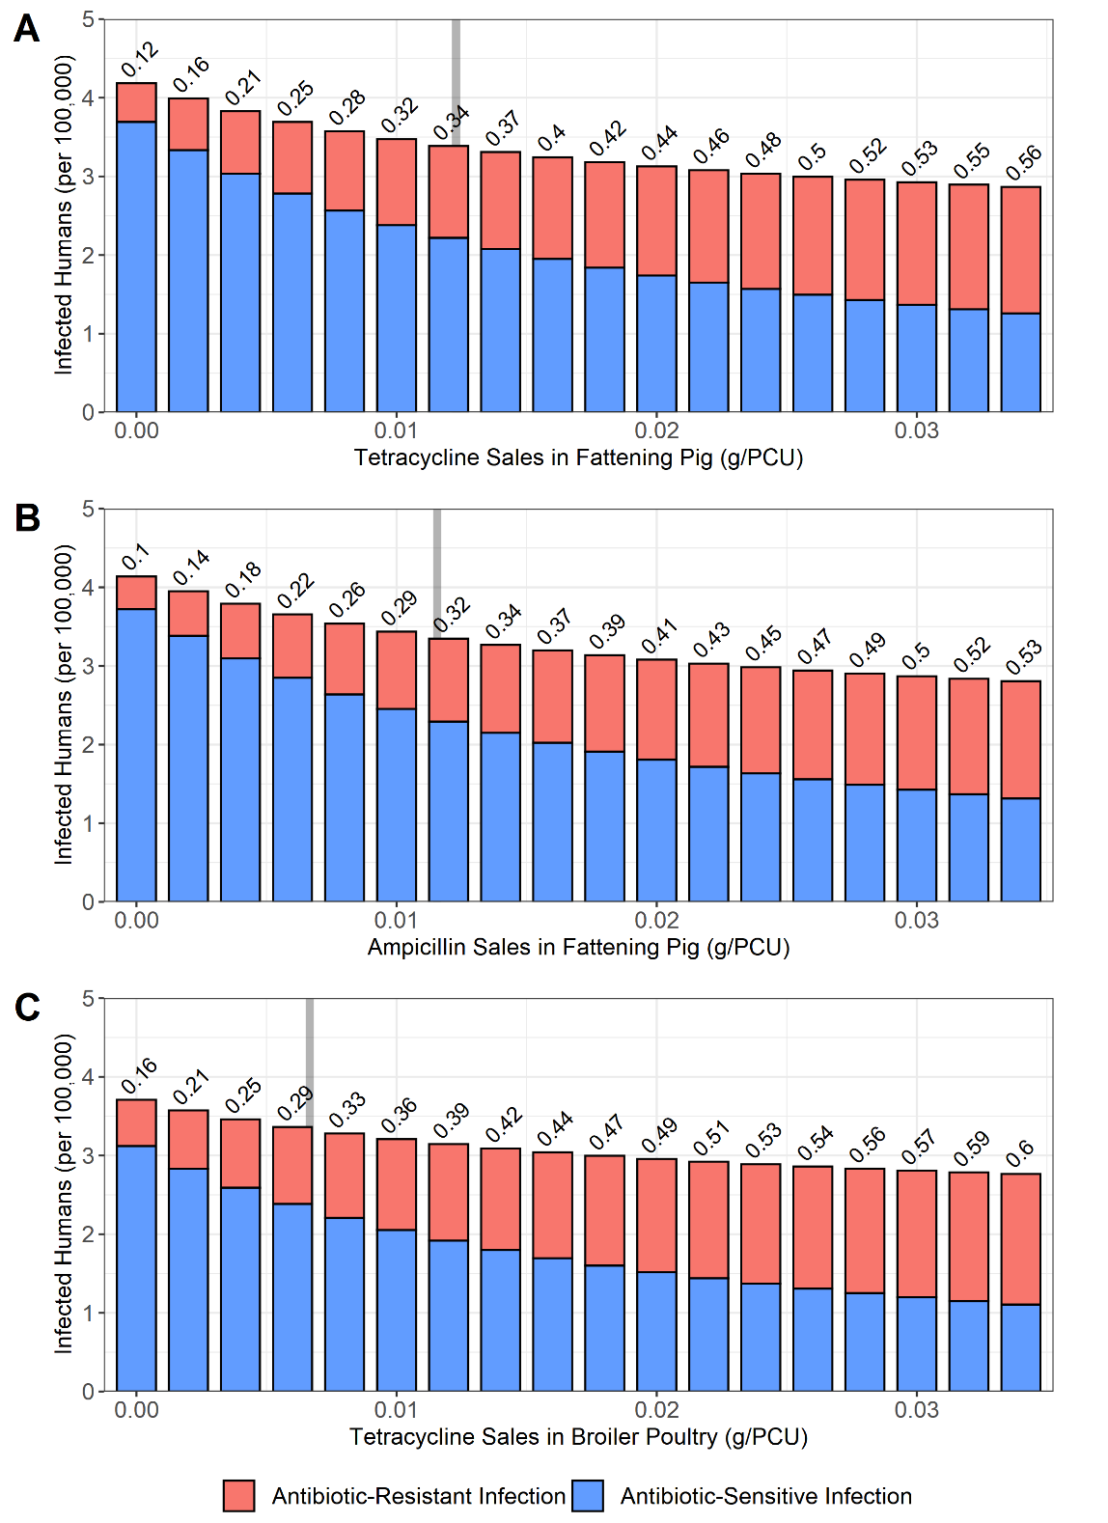

**Figure 3 – Impact of alterations in livestock antibiotic sales (τ) on overall levels of human food-borne disease (ICombH) and the proportion of resistant human infection (ResProp).** A) Tetracycline-resistant human salmonellosis from fattening pigs. B) Ampicillin-resistant human salmonellosis from fattening pigs. C) Tetracycline-resistant human salmonellosis from broiler poultry. Grey bar denotes the case study specific baseline livestock antibiotic sales. Numbers above the bars denote ResProp.

Curtailment of livestock antibiotic usage (*τ* → 0 g/PCU) resulted in small increases in ICombH relative to ICombH at baseline antibiotic sales levels across all case studies (**Figure 3**). Curtailment in the tetracycline-resistance in fattening pigs case study resulted in the largest increase in ICombH with a 1.24-fold (4.19 per 100,000) increase relative to baseline levels, and a 1.23-fold (4.14 per 100,000) and 1.11-fold (3.71 per 100,000) increase in the ampicillin-sales in fattening pigs and tetracycline-sales in broiler poultry case study respectively (**Figure 3C**). Increases in livestock antibiotic usage above baseline usage levels (*τ* > 0.0123/0.0116/0.0067 g/PCU) resulted in the opposite phenomenon being observed, with small decreases in overall human food-borne disease and increases in the proportion of resistant infection (**Figure 3**).

We next identified the parameters which had the greatest influence on relative increases in ICombH when livestock antibiotics were curtailed (*τ* = 0 g/PCU), compared to ICombH at mean baseline livestock antibiotic usage across the three case studies (*τ* = 0.0102 g/PCU) **(Figure 4A)**. This was conducted using the FAST sensitivity analysis approach. The per capita rate of background rate of transmission to livestock populations (*ζ*), animal-to-animal transmission (*βAA*), transmission-related fitness costs of antibiotic resistance (*α*), antibiotic-resistant to antibiotic-sensitive reversion rate (*φ*), efficacy of antibiotic-mediated livestock recovery (*θ*) and natural recovery rate in livestock (*rA*) were found to be the most influential parameters in determining the relative increase in ICombH from baseline livestock antibiotic usage when antibiotics where curtailed. (**Figure 4A**). To explore this sensitivity analysis in more detail, each parameter was altered to explore the individual impact on the relative change in ICombH under livestock antibiotic curtailment compared to ICombH at baseline livestock antibiotic usage (*τ* = 0.0102 g/PCU). Lower *α* and *θ* parameter values, and higher *ζ*, *rA*, and *φ* parameter values resulted in lower relative increases in ICombH when livestock antibiotics were curtailed (*τ* = 0 g/PCU) (**Figure S3**).

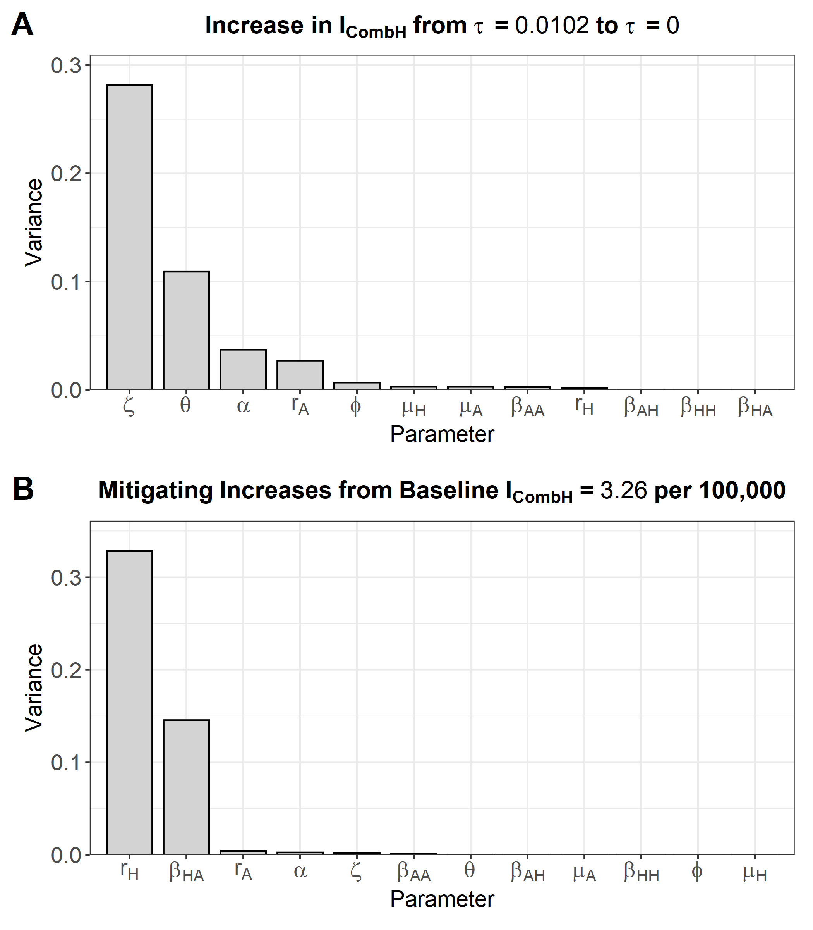

**Figure 4 – Fourier amplitude senstivity test (FAST) to identify the most influential model parameter for: A) The relative change in ICombH under curtailment (0 g/PCU) compared to the averaged baseline antibiotic usage level (0.0102 g/PCU). B) Mitigating changes in ICombH under curtailment compared to the level of foodborne disease experienced under current levels of livestock antibiotic usage (3.26 per 100,000 population).**

A sensitivity analysis was next performed to identify parameters that could best mitigate increases in ICombH under antibiotic curtailment (0 g/PCU). This was explored in the context of preventing increases in ICombH under curtailment, beyond what is observed with current levels of antibiotic usage (3.26 per 100,000). We identified control of the human recovery rate (*rH*) and the per capita rate of animal-to-animal transmission (*βHA*) as the key parameters to mitigate increases in ICombH. To explore this sensitivity analysis in more detail, each parameter was individually altered to explore the parameter-specific impact on relative changes in ICombH under livestock antibiotic curtailment (*τ* = 0 g/PCU) compared to the current baseline ICombH (3.26 per 100,000). Increases to *rH* and decreases to *βHA* resulted in lower relative increases in ICombH under antibiotic curtailment, therefore representing the best parameter alterations to mitigate potential increases in ICombH due to livestock antibiotic curtailment (**Figure S4**).

We note that despite the highly influential nature of *rH* and *βHA* parameters in mitigating increases in ICombH (**Figure 4B**), only *βHA* can be considered alterable, with pharmaceutical interventions unlikely to be effective at altering *rH* (**CITE**). Both *βAA* and *ζ* parameters were also considered as potential intervention targets, despite their low relative efficacy at controlling ICombH (**Figure 4B**). These parameters were considered in the context of current strategies and discourse to promote livestock health in agricultural settings as a control strategy (**CITE**).

Alterations to *βHA*, *βAA* and *ζ* parameters were explored across a multi-dimensional parameter space to identify potential interventions to mitigate increases in ICombH under antibiotic curtailment (0 g/PCU), below a threshold of 3.26 per 100,000 population. This threshold represented a removal of livestock antibiotic selection pressure (0 g/pCU) and a prevention of increases in ICombH above what is already currently observed for human salmonellosis (3.26 per 100,000). Three intervention scenarios were explored 1) reductions to *βAA* and *βHA*, 2) reductions to *ζ* and *βHA* and 3) reductions to both *βAA*/*ζ* and *βHA*. Note that the last intervention scenario represents the most comprehensive package of measures to reduce transmission and contamination of livestock from foodborne bacteria in the agricultural settings. A limited range of transmission parameter reductions were explored for each intervention scenarios.(100% → 75%) (**Figure 5).**

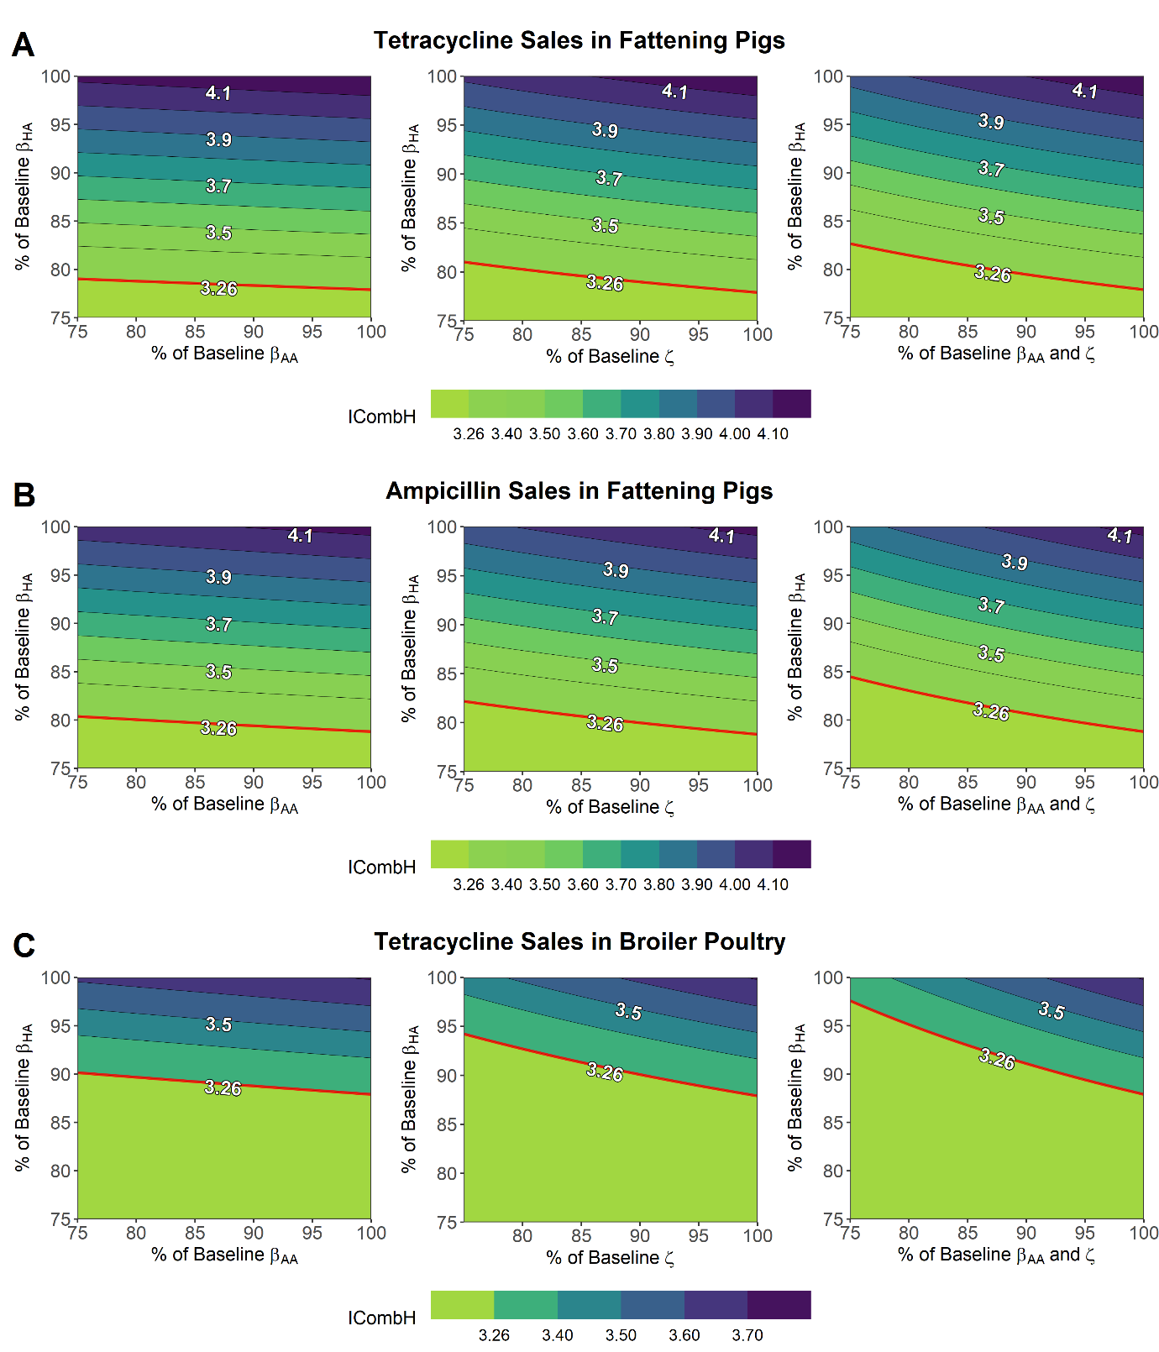

**Figure 5 – Reductions to key model parameters, animal-to-human transmission, animal-to-animal transmission and the background transmission rate to animal populations to mitigate increases in overall human food-borne disease (ICombH) under livestock antibiotic curtailment (*τ* = 0 g/PCU). A) tetracycline-resistance in fattening pigs, B) ampicillin-resistance in fattening pigs and C) tetracycline-resistance in broiler poultry.** Axis represent % reductions to the labelled transmission rate(s). Note that the top right corner of each contour plot represents a scenario with curtailment of antibiotics and no further alterations to any model parameter. The red line represents the threshold at which ICombH is below the levels currently seen with current antibiotic usage (3.26 per 100,000).

Isolated reductions to *βHA* of 23%, 22% and 13% were capable of mitigating increases in ICombH below current baseline levels (< 3.26 per 100,000) for the tetracycline-resistance in fattening pigs (4.19 per 100,000 at 0 g/pCU), ampicillin-resistance in fattening pigs (4.13 per 100,000 at 0 g/pCU) and tetracycline-resistance in broiler poultry (3.71 per 100,000 at 0 g/pCU) case studies respectively (**Figure 5**). In contrast, isolated reductions to *βAA*, *ζ* and both *βAA*/*ζ* parameters were unable to mitigate ICombH below baseline levels across any of the explored case studies. When combined together with *βHA* reductions as a package of intervention measures, joint *βAA*/*ζ* reductions were able to reduce the magnitude of *βHA* interventions required to mitigate ICombH below baseline. This effect varied across case studies, with the greatest effect observed with joint reductions to *βAA*/*ζ* in the tetracycline-resistant in broiler poultry case study, requiring reductions to *βHA* = 3% and *βAA*/*ζ* = 14% to reach threshold levels (**Figure 5B**). This was observed at *βHA* = 18% and *βAA*/*ζ* = 25%, and *βHA* = 16% and *βAA*/*ζ* = 24% for the tetracycline/ampicillin-resistance in fattening pigs case studies respectively (**Figure 5A + C**). We note that the this effect was less pronounced when considering isolated alterations to *βAA* or *ζ* parameters instead.

**DISCUSSION**

Potential increases in non-typhoidal human salmonellosis were identified as a consequence of livestock antibiotic curtailment across tetracycline-resistant salmonella in fattening pigs, ampicillin-resistant salmonella in fattening pigs and tetracycline-resistant salmonella in broiler poultry case studies. This was also accompanied by decreases in the proportion of resistant human salmonellosis with the curtailment of livestock antibiotic usage. Interventions to target animal-to-human transmission, and to a lesser extent, animal-to-animal transmission and background rate of transmission to livestock, were found to mitigate the potential increases in human salmonellosis following a livestock antibiotic curtailment. However, the magnitude of *βHA*/*βAA*/*ζ* reductions required was found to vary across the considered case studies.

Farm-level interventions to mitigate the negative consequences of livestock antibiotic curtailment has been noted in AMR literature and is likely to be a consequence of consequence of ongoing efforts in current agricultural operations (**CITE**). These ongoing efforts include a greater awareness from agricultural/farm workers to provision clean feed, maintain of clean livestock environs and prevention of livestock overcrowding, and has been shown to be efficacious in reducing animal-to-animal transmission and environmental contamination (**CITE**). Post-harvest interventions to reduce microbial contamination on carcasses, as well as comprehensive public information campaigns to promote food safety during handling and cooking of food have also been identified to reduce onwards transmission to human populations (**CITE**). As suggested by efficaciousness of these interventions in controlling the negative human impacts of modelled livestock antibiotic curtailment (**Figure 5**), these ongoing biosecurity will likely help prevent potential increases in human foodborne disease following antibiotic stewardship in livestock.

Additionally, the ability to completely mitigate the negative consequences of livestock antibiotic curtailment in the scenario-specific examples implemented in this study (**Figure 5**), suggests that in certain cases, there is the potential to substitute livestock antibiotics with improved biosecurity to ensure livestock health (**CITE**). However, further research is required to quantify the efficacy of these interventions on the specified transmission routes (**CITE**). Subtle differences in the magnitude of interventions needed to mitigate the adverse human health effects following livestock antibiotic curtailment were also identified across the explored case studies (**Figure 5**). These represent differences in pathogen/livestock combination and agricultural setting, resulting in different transmission-related costs of resistance, antibiotic-mediated recovery efficacies and rates of transmission across case-studies (**CITE**). This suggests a need to consider each case-study and scenario independently, with a universal strength “one size fits all” intervention unlikely to be efficacious across the variety of different settings and pathogen/livestock combinations.

The ongoing discourse to promote livestock biosecurity and improve livestock health motivated the choice to explore both animal-to-animal (*βAA*) and background (*ζ*) transmission parameters, despite the low sensitivity of the model to these parameters (**CITE**). These two parameters were explored alongside the highly important animal-to-human (*βHA*) transmission parameter to assess the efficacy of transmission reductions to mitigate adverse increases in human foodborne diseases upon livestock antibiotic curtailment (**Figure 4B**). Despite the importance of lowering the rate of natural human recovery from foodborne illness (*rH*) on preventing adverse increases in human foodborne disease (**Figure 5 and Figure S4**), the parameter was not considered alterable through human means and therefore excluded from the exploratory analysis. Specifically, increases to *rH* are difficult due to the poor efficacy of treatment to reduce human infection length with foodborne pathogens and due to the already short and relatively low severity of human food-borne illness in the majority of cases (**CITE**).

**Model Assumptions and Limitations**

Livestock antibiotic usage was assumed to decrease the average period of infectious shedding in those infected with antibiotic-sensitive bacteria, consequently increasing the rate of recovery from the ISA compartment. We note that the key determinant of the increases in human foodborne disease following livestock antibiotic curtailment is the extent of this antibiotic-mediated livestock recovery and transmission-related fitness costs. As an illustrative example, preventing livestock antibiotic usage from enhancing the rate of clearance (*θ* = 0) and removing fitness costs (*α* = 0) prevents increases in livestock or consequently human foodborne disease following livestock antibiotic curtailment (**Figure S5**). This is consistent with a number of assumptions in veterinary AMR literature, which suggest limited human health effects following livestock antibiotic curtailment (**CITE**). Further experimental and epidemiological studies must be conducted to confirm the impact of sub-therapeutic and therapeutic antibiotic usage on the period of livestock infectious shedding and the impact of fitness costs of resistance on transmission potential. This will help to validate the assumptions implemented in this study.

The model implemented in this study also assumed a constant rate of antibiotic usage in livestock (τ). This is based on the assumption that livestock populations are routinely exposed to high levels of prophylactic, metaphylactic or growth promoting antibiotic usage, with large levels of intermittent usage being averaged through a constant antibiotic usage rate (**CITE**). This contrasts with the selective and relatively rare usage of antibiotic therapeutics in human populations. Due to the more intermittent and therapeutic nature of antibiotic usage in humans relative to livestock, human-centric models of resistance occasionally stratify the population into explicit “treated” and “untreated” states (**CITE**). In light of recent EU legislation strictly limiting livestock antibiotic usage to therapeutic roles by 2022, it is possible that future insight into the dynamics of livestock resistance may benefit from incorporating features from human models, which describe the intermittent usage of antibiotics (**CITE**).

We use a simplified single parameter (*τ*) to describe the selective pressure and therapeutic effect of livestock antibiotic usage. We model the selective pressure of livestock antibiotics as a single transition rate, encompassing a range of evolutionary and biological phenomena that convert livestock between antibiotic-sensitive to resistant states. One plausible mechanism includes an implicit majority-minority relationship in each infected state, with livestock in the each infected compartment possessing a small proportion of bacteria belonging to the other susceptibility class. Subsequent antibiotic usage may therefore remove antibiotic-sensitive bacteria (ISA) and allow the minority antibiotic-resistant strain to proliferate and dominate (IRA) (**Spicknall - CITE**). We similarly model a single reversion parameter to encompass a range of different biologically plausible phenomena that may cause reversion of antibiotic-resistant (IRA) to sensitive strains (ISA). This includes a relative fitness advantage of antibiotic-sensitive strains and the potential for resistant strains to gain compensatory mutations to reduce fitness costs (**CITE**).

We note that the simplification of the system proposed in this study “builds in” co-existence through the use of implicit transition rates between antibiotic-resistant and sensitive infection states (**Figure S6**). This violates the concept of null-neutrality, a hypothesis originally conceived in evolutionary theory, and adapted in AMR modelling to prevent unrealistic assumptions when exploring the mechanisms driving strain co-existence dynamics (**50/50 STRAIN LIPSITCH - CITE**). However, the absence of this in our model can be justified, as we note that it was not the intention or aim of this study to mechanistically explore the dynamics of co-existence. Nevertheless, as highlighted by Davies et al, (**CITE** – **both papers**) explicitely modelling mechanisms driving coexistence through models which conform to null-neutrality may have extensive implications on the potential impact of modelled interventions (**CITE**). Future modelling into livestock antibiotic curtailment may therefore benefit from model comparison and exploratory modelling to assess the effect of assumptions, model structure and explicit modelling of biological phenomena on the impact of modelled interventions.

Non-typhoidal salmonella (NTS) was modelled in this study as the primary pathogen of interest, with resistant NTS being noted as an antibiotic-resistant pathogen of global concern (**CITE** [**https://www.ncbi.nlm.nih.gov/pmc/articles/PMC4768623/**](https://www.ncbi.nlm.nih.gov/pmc/articles/PMC4768623/) **+ UK 5 AMR year plan).** We note that the tetracycline/ampicillin usage case studies were not chosen due to their clinical relevance, rather due to the high level of usage in both the modelled livestock species and in humans, and with sufficient EFSA data available for these drug/bug/livestock combinations (**CITE**). While fluoroquinolone/azithromycin resistance has more clinical relevance for NTS due to their use to treat invasive NTS, we note that stewardship has already driven usage of these antibiotics in livestock to a sufficiently low level (with bans also in place) (**CITE**). Therefore, it was not feasible to use these antibiotics as a case study for the impacts of livestock antibiotic curtailment.

A prevalence of 3.26 per 100,000 population was chosen for the study baseline for the level of human salmonellosis experienced at baseline (current) antibiotic usage for all case studies (**CITE**). We note that this should not be interpreted that the particular livestock/resistance is the sole contributor to levels of human salmonellosis, rather that the particular livestock/resistance combination is a generalisation for all potential sources of livestock salmonellosis to aid model parameterisation. This was solely done to aid model parameterisation, in the absence of explicitely stratifying the livestock population and modelling the dynamics in every food animal species. However, we note that this is a simplification and should be explored in future modelling to identify the impact of heterogeneity in host, antibiotic usage, and livestock carriage of foodborne pathogens on the dynamics observed in this study. Additional insight could also be gained by expanding the *βHA* transmission pathway to explicitely model the complexities associated with livestock-to-human transmission of foodborne pathogens. This could include modelling the contamination of food products during processing and with foreign importation of contaminated food products (**CITE**).

Additionally, we note the data limitations of the model fitting approach used in this study for the three case-studies. There is currently a dearth of high quality livestock datasets regarding carriage of foodborne pathogens, especially when compared to availability of human datasets (**CITE**). Therefore, it is more useful to consider the parameterisation in this study as a method to ground the model in reality across diverse parameter values, rather than an exact reflection of each case study. Despite the limitations of this data-driven modelling approach, we note that this is a significant improvement compared to an arbitrary parameterisation of the model system. Future improvements to AMR surveillance will likely facilitate improvements in the accuracy of future model fitting of livestock AMR models (**CITE**).

We note that there is currently no consensus on the definitive impact of antibiotic withdrawal on the carriage of foodborne pathogens in livestock or prevalence of foodborne disease in humans. However, this study identifies that if a “worst case” scenario was observed, with a loss of antibiotic pressure resulting in increases in livestock contamination and foodborne disease, then moderate strength biosecurity interventions would be sufficient to mitigate any detrimental human health effect. This was identified under the exploratory assumption that livestock antibiotics have a therapeutic effect in livestock to reduce the duration of infectious shedding, and the presence of livestock-to-human transmission of antibiotic-resistant foodborne bacteria. These findings have particular relevance in recent years, with antibiotic stewardship programs adopting a holistic “one-health” approach to mitigate increasing antibiotic-resistance in humans and an intensifying focus on improving livestock welfare to prevent human disease (**CITE**).

It is important to note that the model and assumptions described in this study were not intended to predict the definitive consequences following alterations in livestock antibiotic usage. The study instead aimed to quantify the dynamics arising from several potential consequences of livestock antibiotic usage. Therefore, it is important to contextualise the work of this study with the ever increasing amount of epidemiological, modelling and genomic work being undertaken to better understand the global problem of anti-microbial resistance.